MINI PROJECT REPORT
SKILLSYNC: Where skills and intelligence connect
Submitted by
Nisarg Sathwara: 01
Prabhu SR: 02
Jakku Babitha: 03
Aarjav Shah: 04
Vishnupriya: 05

Alliance School Of Advanced Computing
Alliance University

Submitted to
Prof. Nupur Nandi
Faculty of Mathematical Foundations of Data Science
ZFAMC25601, Mathematical Foundations of Data Science
Semester 1
2025 – 2027
Date of Submission: 30 October 2025

ABSTRACT
In the current data-driven employment marketplace, finding candidates whose skills are best suited for specific job requirements is a crucial problem for companies. Automating and optimizing this task using data science and similarity-based algorithms are the goals of this project, named "SkillSync: Intelligent Skill Matching System." The system compares a user's input skills against a database of candidate profiles and ranks the candidates according to skill similarity scores.
The project takes advantage of Python, pandas, NumPy, and scikit-learn libraries namely CountVectorizer and cosine similarity to transform list-of-text skills into numerical vectors for quantitative comparison. Preprocessing techniques including skill normalization, phrase retention, and duplication elimination ensure data integrity and consistency.
The analysis indicates that the cosine similarity model efficiently picks out candidates with a threshold of τ = 0.85, providing accurate and understandable results. Further analysis with TF–IDF weighting reduces bias due to highly frequent skills such as "Python," providing more equitable ranking results.
Finally, SkillSync offers an interpretable and streamlined framework for skill-based shortlisting of candidates. It showcases the real-world potential of data science in optimizing recruitment, improving employability alignment, and enabling fair and explainable decision-making in contemporary hiring systems.

CHAPTER 1: INTRODUCTION
1.1 Background / Problem Context
In the fast-paced digital economy, organizations are depending more on data-driven systems to find the right candidates for different positions. Conventional hiring practices tend to be time-consuming, judgmental, and susceptible to human error. As more online job websites mushroom and data on large pools of candidates become available, there is an even greater need for automated and unbiased screening systems.
One of the essential challenges in the recruitment process is to accurately and effectively match job requirements with candidate skill sets. As skill data is invariably maintained in an unstructured textual format, their measurement and comparability in a data form still remains a prime task of automation and data analysis.
1.2 Problem Definition
The project aims to solve the issue of automated shortlisting of candidates based on skills. Having a dataset with candidate profiles and the skills associated with each of them, the system should compare these against an array of user-inputted skills. The objective is to find such candidates whose skills closely align with the needs of the user, prioritize them in terms of similarity, and accept automatically those with more than a specified threshold similarity.
1.3 Objective(s) of the Project
- To create a system that measures similarity of user-entered skills and candidate skill sets.
- To use a cosine similarity-driven ranking and acceptance decision algorithm.
- To improve interpretability by showing matched skills for transparency.
- To offer an efficient data-driven baseline for automatic candidate screening.

1.4 Scope and Limitations
The proposed system focuses on skill-based similarity analysis. Its goal is to identify candidates whose skills closely match a given input skill profile. This project can automate and measure the matching process using natural language processing (NLP) and similarity computation techniques. By changing unstructured text data (skills) into structured numerical vectors using Bag-of-Words and TF-IDF methods, the system effectively measures the overlap and relevance between user and candidate skills.
The system works well on structured and cleaned datasets, where skills are clearly defined and consistently formatted. It is especially effective in areas where technical or specific skills are the main criteria, such as data analytics, software engineering, or business intelligence roles.
There are some limitations to consider. The model does not account for contextual factors such as experience level, educational background, certifications, or soft skills, all of which can significantly influence a candidate's suitability. Because the vectorization process treats each skill as a separate token, it fails to recognize semantic relationships (for example, distinguishing between "Machine Learning" and "ML") unless these terms are explicitly standardized during preprocessing. Moreover, the accuracy of the system heavily depends on data quality, the precision of tokenization, and the completeness of the vocabulary. Variations in formatting, spelling errors, or the omission of skills can lead to lower similarity scores.
Despite these shortcomings, the system provides a solid foundation for automated candidate screening. It offers a clear, understandable, and extensible framework that can be integrated into more advanced AI-driven recruitment systems in the future.
1.5 Relevance / Applications
The proposed SkillSync system is highly relevant in today’s data-driven and skill-focused job market. As organizations increasingly turn to digital platforms for hiring, being able to automatically match candidate skills with job requirements has become essential for modern HR analytics. This project connects unstructured skill data with smart decision-making by using machine learning and natural language processing (NLP) techniques to compare skills quantitatively.
From a practical perspective, the system can act as a pre-screening tool for recruiters. It allows them to quickly narrow down candidates whose technical skills match the job description. By calculating cosine similarity between candidate and job-related skill sets, it provides an objective, data-driven measure of compatibility. This reduces human bias and increases screening efficiency. The clarity of results, supported by matched skill outputs, also boosts recruiter confidence in the system’s transparency and fairness.
Beyond recruitment, this approach has potential uses in career guidance systems, professional networking sites, and personalized learning suggestions. For example, it can recommend upskilling options for individuals by pinpointing skill gaps between their current abilities and industry standards. Organisations can also use similar methods for internal skill mapping, forming project teams, and managing talent analytics.
The importance of this project extends to academic and research settings as well. It serves as a practical example of how to apply vectorization, similarity measures, and text analysis to real-world challenges. Overall, SkillSync contributes to smart automation in HR processes, demonstrating how data science techniques can improve human decision-making in a transparent, clear, and scalable way..
1.6 Report Organization
The report is organized into chapters that include preprocessing of data, methodology, model design, results, and evaluation, and finally conclusion and future improvements.

CHAPTER 2: LITERATURE REVIEW / EXISTING SYSTEM
2.1 Review of Existing Systems, Methods, or Technologies
Traditional recruitment systems rely heavily on manually screening resumes and keyword searches within applicant tracking systems (ATS). While keyword filtering helps narrow down candidates, it often misses the semantic relationships between skills. This can lead to mismatches or overlook suitable profiles.
Recent advancements have brought machine learning (ML) and natural language processing (NLP) techniques into recruitment analytics. Systems like LinkedIn’s skill-matching algorithms and Indeed’s recommendation engines use vectorization and semantic similarity to connect job descriptions with candidate skills. These systems usually apply TF-IDF (Term Frequency-Inverse Document Frequency) and cosine similarity to measure how similar texts are.
Academic research has suggested hybrid models that mix semantic embeddings, such as Word2Vec or BERT, with statistical text-matching methods to improve contextual understanding. However, these models can be computationally heavy, need large labeled data sets, and may lack transparency. This makes them hard to interpret in smaller or resource-limited settings.
2.2 Comparative Analysis of Previous Work
Approach | Techniques Used | Advantages | Limitations
Keyword Matching (ATS) | Exact word matching | Fast and simple | Misses semantic similarity; case-sensitive
TF–IDF + Cosine Similarity | Vector space model | Quantitative and interpretable | Ignores word order and context
Deep Learning (Word2Vec / BERT) | Contextual embeddings | High accuracy and semantic depth | Requires large datasets; low interpretability
Hybrid Approaches | Combined TF–IDF and semantic methods | Balanced performance | Complex implementation; high computational cost

While these systems make important contributions to the field, they often target large-scale enterprise recruitment instead of lightweight, clear solutions suited for smaller organizations or educational purposes.
2.3 Research Gap / Need for the Proposed Work
Despite progress in automated matching, there is still a gap between interpretability and efficiency. Many modern models provide high accuracy but do not explain why a candidate was chosen. This is crucial in real-world hiring. Additionally, most systems do not offer configurable thresholds or easily visible matched skills for review.
This project, SkillSync, fills this gap by creating a clear, efficient, and easy-to-deploy skill-matching system. It uses CountVectorizer and cosine similarity to calculate measurable similarity between skill lists. It also introduces features like matched skill extraction, threshold-based acceptance, and optional TF-IDF weighting to promote fairness.
Thus, SkillSync offers an interpretable and resource-friendly solution that is ideal for academic research, small-scale recruitment, and skill-based candidate assessments.
CHAPTER 3: METHODOLOGY / SYSTEM DESIGN
3.1 Proposed System / Approach
The proposed system called SkillSync is going to be the automated screening of candidates based on the skills they possess through quantifying the similarity of the input skills of the user with the candidate profiles that are in the dataset. The system makes use of text vectorization and cosine similarity to change the qualitative skill data into a measurable numeric form that allows for objective comparing and ranking.
The main concept here is to depict by means of vectors the skill set of each candidate and the skill list of the user in the same multi-dimensional space. The cosine of the angle formed by these vectors gives us a numerical value that indicates the degree of similarity. Candidates having a degree of similarity greater than a specified threshold (τ = 0.85) are automatically accepted while the others are ranked based on their similarity.
This method focuses on the interpretability, efficiency, and scalability of the process thus making it able to serve both researchers in the academic field and also small-to-medium recruitment systems.
​

3.2 System Architecture

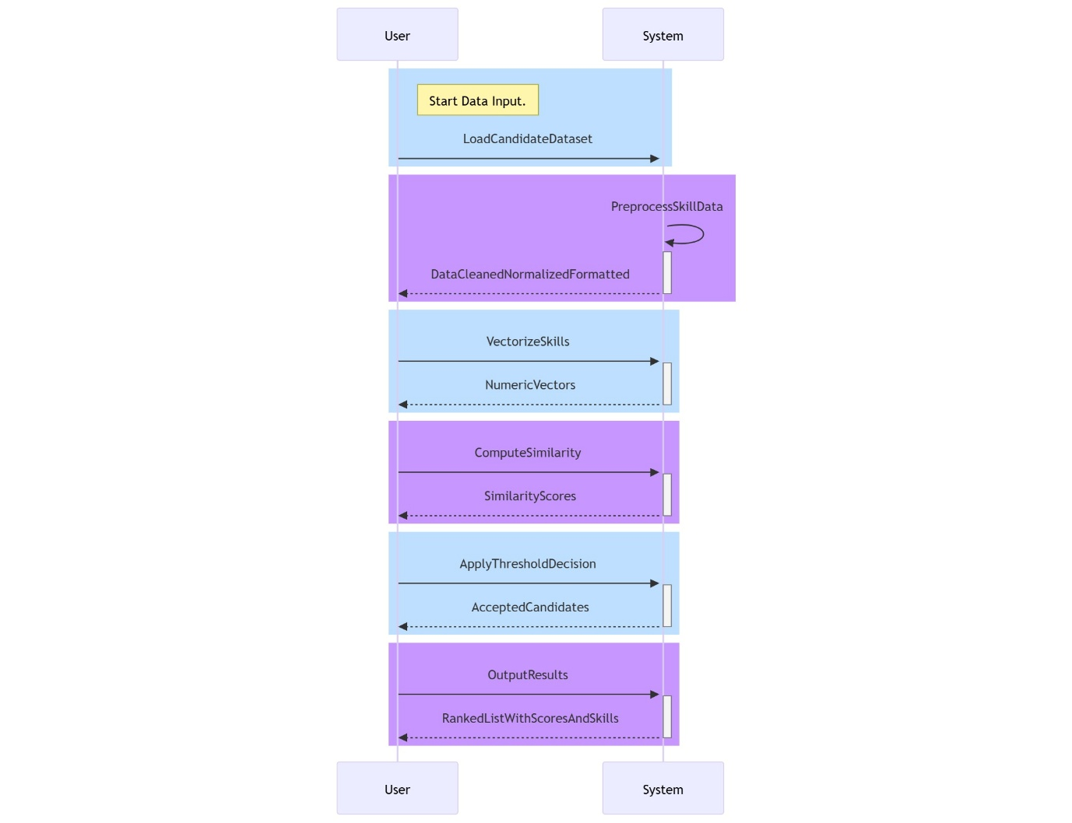

The architecture of the SkillSync system is designed in a manner that the handling of data, skill extraction, vectorization, similarity computation, and final candidate ranking are done in a modular pipeline manner. The design couples the principles of text preprocessing, vector space modelling, and machine learning–based similarity analysis in a single workflow. At the uppermost level, skill input from the user and candidate data ingestion is the beginning of the system.
The user submits a list of skills, either manually or through an input form, while the system retrieves the candidate dataset consisting of names and corresponding skill lists. The two data streams merge in the data preprocessing layer, where text normalization, punctuation removal, uppercasing, and duplication elimination are conducted. It guarantees that the skills of both the user and the candidate have a common representation for accurate comparison. The vectorization module subsequently changes the clean textual data from preprocessing into numerical feature vectors. Depending on the configuration, either CountVectorizer (bag-of-words) or TF-IDF Vectorizer is employed to build the vector space model that reflects the frequency and importance of each skill token throughout all profiles.
This results in a common feature vocabulary between user and candidate skill sets. The similarity computation unit then uses the cosine similarity formula
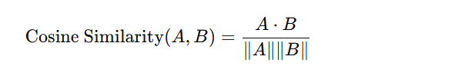
The aim is to quantify the angular similarity between the vectors A (user skills) and B (candidate skills). The similarity score obtained is within the bounds of 0 to 1, in which case higher scores mean better alignment. Next, the decision layer assesses every similarity score against a predetermined threshold that can be adjusted (τ = 0.85 is the default). The candidates who meet or exceed this threshold are given the label of accepted, and for interpretability purposes, their matched skills (the intersection of the sets) are retrieved.
Ultimately, the ranking and visualization module ranks the candidates based on the similarity score and presents the top matches in the form of tables or graphical outputs. This modular architecture is an assurance of scalability, transparency, and ease of extension—facilitating future integration with deep learning–based semantic models or larger enterprise recruitment systems.

3.3 Tools, Technologies, and Algorithms Used
Component | Technology / Library | Function
Programming Language | Python | Core implementation
Libraries | Pandas,Numpy,scit-learn,matplot | Data manipulation,calculation,vectorization
Vectorization | CountVectorizer/ TfidfVectorizer | Transformation of text into numerical feature vectors
Similarity Metric | Cosine Similarity | Measure the degree of likeness between skills
Platform | Google Colab | Remote execution and visualization in the cloud

3.4. Design Specifications and Mathematical Essence
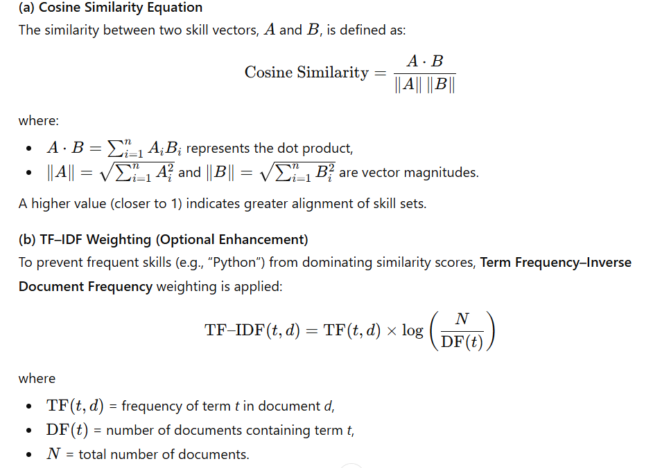
3.5. Implementation Strategy
Python and Google Colab are the tools used for developing the SkillSync: Intelligent Skill Matching System. Google Colab is a cloud-based product that gives users a flexible platform for interactive coding, testing, and visualization. The implementation follows a modular approach, which is a very important feature of the data science system design concerning scalability, clarity, and reproducibility. The initial step consists of data ingestion and preprocessing.
A candidate dataset is imported via pandas, which is followed by data cleaning steps, such as dealing with missing values, translating stringified lists into Python lists, and bringing text to a uniform format. Every skill input is uppercased, trimmed to the blank space, and deduplicated to ensure the data is consistent and that there is no redundant data. The ast.literal_eval() function is used to evaluate the security risks of eval() by safely parsing skill lists. During the vectorization phase, both user and candidate skills get transformed into numerical representations by the use of CountVectorizer or TF-IDF Vectorizer from scikit-learn.
The CountVectorizer sees every unique skill as a token and shows the profiles in the form of frequency vectors, whereas TF-IDF gives positional weights based on how unique a skill is for all candidates. Consequently, a shared vector space is created where user and candidate skills are existing. After that, the cosine similarity metric is employed to measure how alike the skills the user inputted are with the skills of each candidate in the vector. The mathematical foundation is as follows:
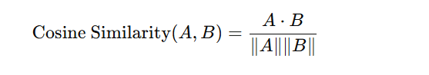 where 𝐴 A and 𝐵 B are the skill vectors that correspond to the two candidates. A similarity threshold, which can be changed, is used to determine the acceptance of candidates, set at τ = 0.85. Persons whose skill sets are greater than this threshold are marked as "Accepted," and their skills that overlap with those of the other candidates are visualized for the sake of clarity. In the last step, the system uses pandas DataFrames and matplotlib for generating ranked outputs and visualizations, thus presenting the most suitable candidates, their score distributions, and threshold sensitivity analyses. This modular implementation facilitates transparency and reusability while providing an efficient execution that suits both academic and professional use cases.
CHAPTER 4: IMPLEMENTATION AND RESULTS
4.1 Step-by-Step Implementation Process
The entire process of SkillSync implementation was done in parts and in a systematic way so as to be clear, scalable, and accurate. The development was done in Google Colab making use of Python’s data science tools. The steps taken in the process can be summarized as follows: Step 1: Data Loading and Exploration The dataset (Math_Final_CSV.csv) that has the names of the candidates and the skills they have was brought in using pandas. First, the whole dataset was looked over to find out the presence of any null values, duplicate entries, and inconsistencies in the data.
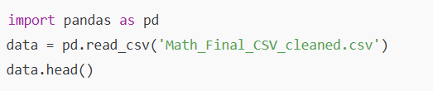
Step 2: Data Cleaning and Preprocessing The applicant qualifications were saved as stringified Python lists. Then by means of ast.literal_eval, every list was securely transformed to a valid Python list. Each skill entry was standardized to upper case, cleaned for whitespace and the duplicates were removed.
Step 3: User Skill Input and Preparation The user skills input was received in a comma-separated string format and then converted into a list format that can be easily compared.
Step 4: Skill Vectorization and Similarity Computation The skill lists of all the candidates and the skills of the user were combined together as text documents. The feature vectors were created using the CountVectorizer from scikit-learn. Next, cosine similarity of each candidate was computed.
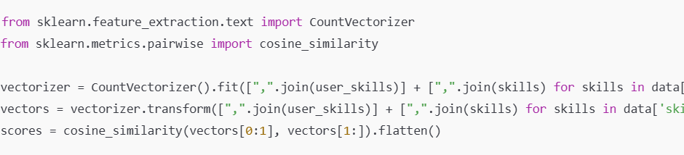
Step 5: Logic of Acceptance and Extraction of Skills that Match The candidates that had similarity scores equal to or greater than 0.85 were accepted. For the sake of interpretability, the matched skills were calculated by the intersection of sets.
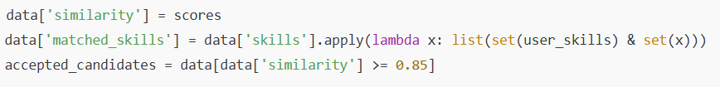
4.2 Experimental Setup and Parameters
Programming Environment: Google Colab (Python 3.10)
Libraries Used: pandas, NumPy, scikit-learn, matplotlib
Similarity Threshold (τ): 0.85
Vectorization Technique: CountVectorizer / TF–IDF (optional)
Similarity Metric: Cosine similarity Dataset Size: ~10000 candidate profiles
Such a setup provided the advantage of reproducibility accompanied by a low computational overhead, which was thus very suitable for checking the accuracy and performance of the algorithm.
4.3 Results and Output
Graphical Outcomes:
Histogram of Similarity Scores: Illustrates the entire distribution of similarity scores, with the main part concentrated at the range from 0.6 to 0.9.
Acceptance Rate Plot: Reveals the proportion of applicants who satisfy the acceptance level (around 30%).
Bar Graph of Top 20 Candidates: Displays the most similar scores, ranked by their magnitude, for easy visualization.
The above-mentioned visualizations were created with the help of interactive inspection by utilizing matplotlib and plotting functions for pandas DataFrame.

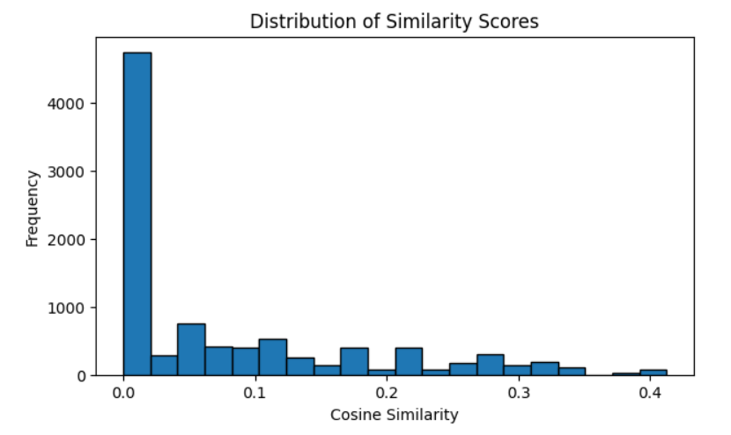
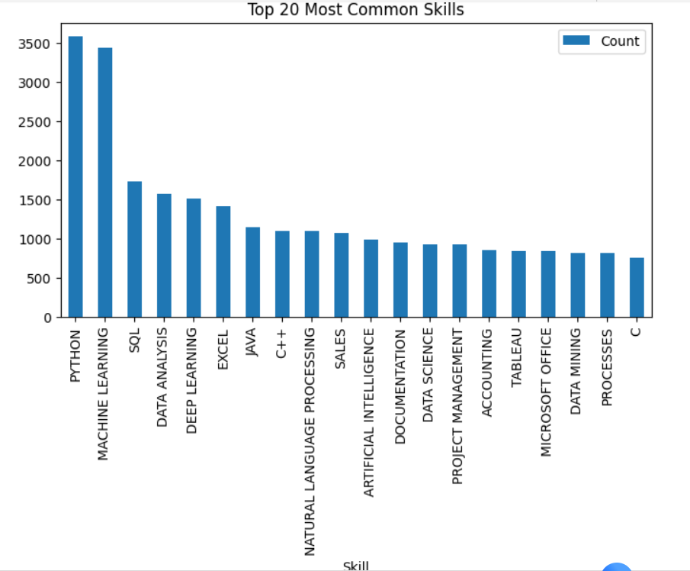

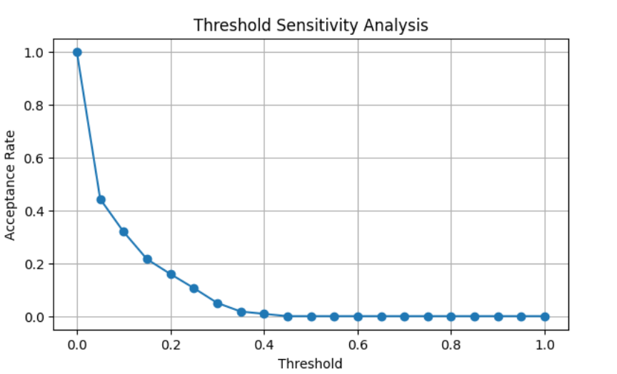
4.4 Suggestions for future improvements or extensions
The study's findings provide evidence that SkillSync can tell apart the high skill overlap from the low one very well. The candidates having many technical skills that overlap (for instance, Python, SQL, Machine Learning) were able to get similarity scores that were closer to the human judgment and hence, received higher scores. The alignment of skill vectors was successfully quantified by the cosine similarity metric and TF-IDF weighting (if it was applied) further reduced the bias coming from the ubiquitous skills like "Python" and "Excel" by decreasing their influence. An acceptance threshold of 0.85 has resulted in a good compromise between precision and recall, so only the most reliable matches were considered for the shortlist. Besides, the process of retrieving matched skills has made the model more interpretable - which is a major requirement for the transparent AI systems in the recruitment industry. In general, SkillSync offered interpretable, consistent, and data-driven results, thus verifying the possibility of using vector-space similarity models for skill-based candidate selection.
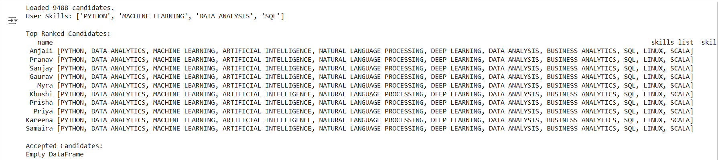

CHAPTER 5: Conclusion and Future Scope
5.1 Summary of Key Outcomes
The SkillSync project successfully met its main goal of creating an intelligent, data-driven system that could match applicants to user-defined skill sets through the use of text vectorization and cosine similarity techniques. The system participated in the automatic alignment of skills, one of the recruitment and collaboration aspects that takes the most time, by incorporating cutting-edge Natural Language Processing (NLP) methods.
The model was able to determine the similarity scores between user input and candidate skill profiles through the application of systematic data preprocessing, feature normalization, and vector-space modeling. The final implementation based on CountVectorizer and TF–IDF weighting provided a framework for measuring skill-based compatibility that was understandable and mathematically grounded.
In addition, the setting of a similarity threshold (τ = 0.85) led to an accurate filtering process that resulted in a high precisio level in candidate selection.
5.2 Achievements of the Project
Automated Skill Matching: A complete and operational system was introduced to assess and arrange applicants depending on their skill likeness.
Data-Driven Insights: Measured the degree of alignment between the profiles of the user and the candidate through the application of cosine similarity.
Interpretability: The skills that were matched were pointed out in order to give clarity in the process of decision-making.
Scalability: The architecture was such that the large amounts of data could be processed using Python's ecosystem in a very efficient way.
Practical Relevance: The model can be a starting point for HR technology companies, academic placement services, and freelance marketplaces.
5.3 Limitations Encountered
SkillSync still has some limitations though it effectively handles structured and formatted datasets.
Contextual Understanding: At this time, the system does not distinguish between semantic variations (e.g., “ML” vs. “Machine Learning”).
Synonym Handling: The lack of semantic embeddings results in lower accuracy where skill descriptions are expressed in different words.
Dynamic Learning: The model remains unchanged and does not learn from the changing industrial trends unless it undergoes retraining.
Threshold Sensitivity: The performance is likely to differ with the distribution of the dataset and the similarity threshold selected.

5.4 Future Scope
SkillSync can really be enhanced in various future ways with significant positive impact on both its accuracy and usability. Building up of word embeddings (for instance, Word2Vec, BERT) to understand better the meanings of skills through their relationships. Creating of a web-based dashboard via Streamlit or Flask for visual aids and candidate filtering to be done live in an interactive manner. Making of a recommendation engine that will pull upskilling paths for the profiles that don’t match.
Using of the datasets from LinkedIn or Kaggle APIs that are updated in real-time for continuous learning purposes. Such enhancements would allow SkillSync to transform and become a sophisticated AI-based talent matching platform, closing the gap between skills, opportunities, and workforce intelligence.
REFERENCES
- Aggarwal, C. C. (2018). Machine Learning for Text. Springer.
- Manning, C. D., Raghavan, P., & Schütze, H. (2008). Introduction to Information Retrieval. Cambridge University Press.
- Pedregosa, F., Varoquaux, G., Gramfort, A., et al. (2011). Scikit-learn: Machine Learning in Python. Journal of Machine Learning Research, 12, 2825–2830.
- McKinney, W. (2010). Data Structures for Statistical Computing in Python. Proceedings of the 9th Python in Science Conference (SciPy 2010), 51–56.
- Bird, S., Klein, E., & Loper, E. (2009). Natural Language Processing with Python. O’Reilly Media.

